Problem: add image to <p:calendar> button!

Solution:

* Find image fit with button like button have size 48x48 px, we need to find icon have same size.
* after that add into css file 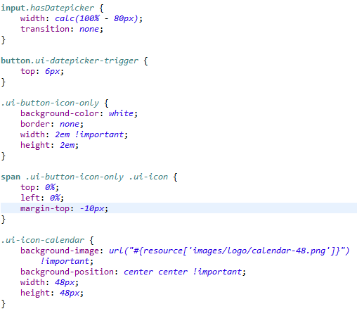
* you can edit a little bit to fit with your form.

**Problem : Cannot add new employee when user type Vietnamese or Swedish**

Solution : Use the StandardCharsets.UTF_8 in RestClient where we convert Json to object and object back to Json.

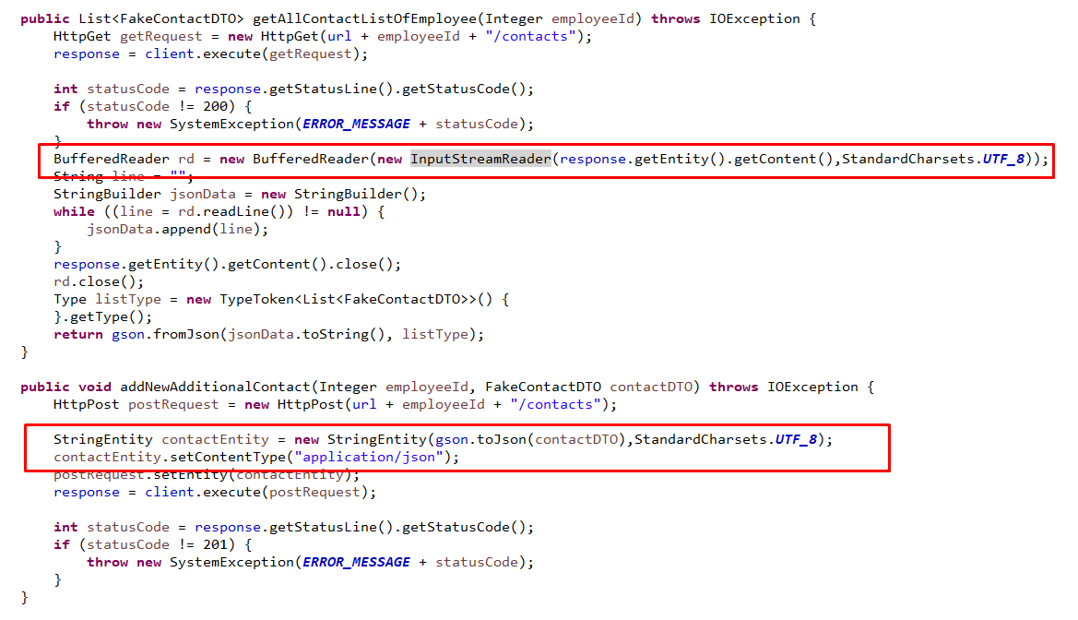

**Problem : Want to show error message on UI by using JSF ( not by using Javascript - because when we use Javascript we need to consider all conditions and write manually)**

Solution :  Use FacesContext.getCurrentInstance().addMessage(clientID,new FacesMessage(message);

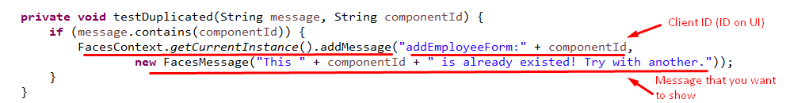

**Problem : Want to show blue color underline in password field on UI same as inputText field**

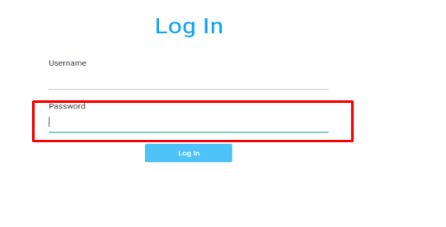

Solution :  Add this one for password in the aavn-form-components.min.css

*.aavn-form-component* *.aavn-input-field* *.aavn-input-text.ui-inputfield.ui-password.ui-widget.ui-state-default.ui-corner-all.ui-state-focus*

{

border-bottom: *1px* *solid* *#4dc3f9*;

box-shadow: *unset*

}

**Problem : We can’t use @Named(value= “name”) for @SessionScoped**

Solution : We use @ManagedBean(name= “name”) for @SessionScoped

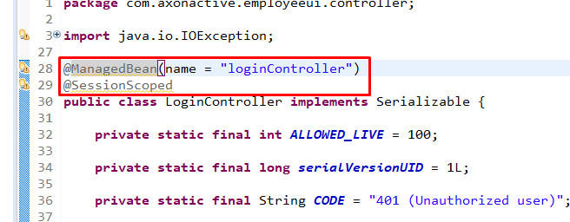

**Problem : While we search , If we enter , then it goes to add-employee.xhtml page directly**

Solution : Because before we used just one form for the whole employee-list.xhtml page. So when we enter it submit the form and redirect to add-employee.xhtml . So , we now used separate two forms for search and employee-list . Current , while we search and enter , it show the result of search.

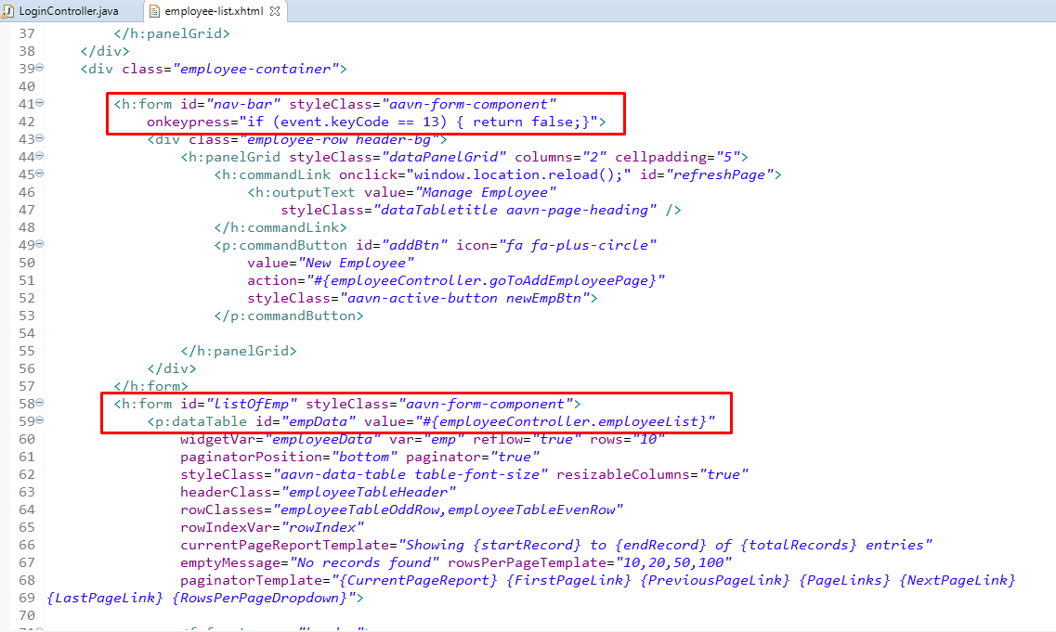

**Problem : [Bug] In update the employee , we can submit the update form while the required filed are empty .**

Solution : Because before we use <p:commandbutton> with “immediate=true” , so jsf don’t check the validation when submit the form . So , we remove “immediate=true” . Also we use two forms for button and input text (unnecessarily) . We make mistake for that. So , we change to using only one form .

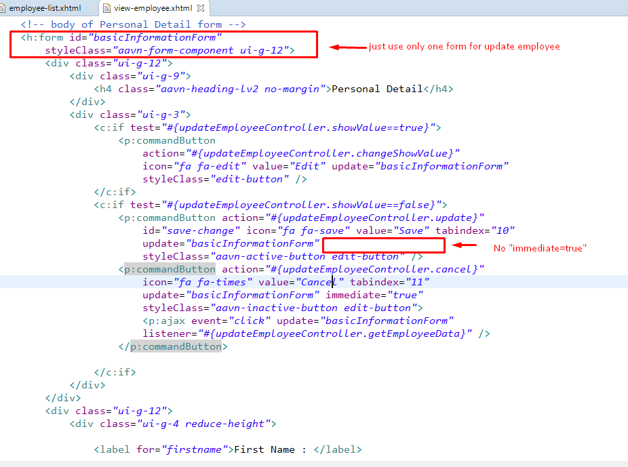

Scenario : Our view-employee.xhtml have long code and we need to use dialog for add contact or add certificate . So , we don ‘t write more code in same page , we implement in new xhtml file, and call that one as dialog .

**Problem : At first , we use PrimeFaces.current().dialog().openDynamic() and .closeDynamic() to open another xhtml file as dialog . But that one didn’t support the Hide Dialog , only support close dialog , it didn’t check validation and close immediately . So we can’t use that way .**

Solution : We now use just <p:dialog> and inside <p:dialog> we call another xhtml file as ui component.

Call another page with <ui:include src = “pagename”>

And that xhtml file should be write in <ui:composition>

